Lab Exercise - Configure Prometheus and Grafana for Azure VM Monitoring using Azure Cloud Shell

Objective
In this lab, you will:
- Create an Ubuntu Virtual Machine
- Configure NSG inbound rules
- Install Docker
- Deploy Node Exporter
- Deploy Prometheus
- Deploy Grafana
- Connect Grafana with Prometheus
- Visualize Azure VM metrics in Grafana dashboards
using Microsoft Azure Cloud Shell.

Architecture
Azure VM
|
Node Exporter (9100)
|
Prometheus (9090)
|
Grafana (3000)
|
Monitoring Dashboard

Concepts Covered
- Azure Virtual Machine
- Docker
- Prometheus
- Grafana
- Node Exporter
- Metrics Visualization
- Infrastructure Monitoring

Real-World Scenario
Organizations use:
- Prometheus for metrics collection
- Grafana for dashboards and visualization
to monitor:
- CPU
- Memory
- Disk
- Network
- System performance

Lab Configuration
Resource | Value
Resource Group | rg-grafana-lab
VM Name | vm-monitor
Username | azureuser
VM Size | Standard_B1s
OS | Ubuntu 20.04
Region | centralindia

Prerequisites
- Azure Subscription
- Azure Cloud Shell access

Step 1: Open Azure Cloud Shell
Open:
Azure Portal
Launch:
- Cloud Shell
- Bash

Step 2: Create Resource Group
az group create \
--name rg-grafana-lab \
--location centralindia

Step 3: Create Ubuntu VM
az vm create \
--resource-group rg-grafana-lab \
--name vm-monitor \
--image Canonical:0001-com-ubuntu-server-focal:20_04-lts-gen2:latest \
--size Standard_B1s \
--storage-sku Standard_LRS \
--admin-username azureuser \
--generate-ssh-keys \
--public-ip-sku Standard

Wait 2–5 minutes.

IMPORTANT: Open Ports Immediately

Step 4: Open SSH Port (22)
az vm open-port \
--resource-group rg-grafana-lab \
--name vm-monitor \
--port 22 \
--priority 1004

Step 5: Open Prometheus Port (9090)
az vm open-port \
--resource-group rg-grafana-lab \
--name vm-monitor \
--port 9090 \
--priority 1001

Step 6: Open Node Exporter Port (9100)
az vm open-port \
--resource-group rg-grafana-lab \
--name vm-monitor \
--port 9100 \
--priority 1002

Step 7: Open Grafana Port (3000)
az vm open-port \
--resource-group rg-grafana-lab \
--name vm-monitor \
--port 3000 \
--priority 1003

Step 8: Verify NSG Rules
az network nsg rule list \
--resource-group rg-grafana-lab \
--nsg-name vm-monitorNSG \
-o table

Step 9: Get VM Public IP
az vm list-ip-addresses \
--resource-group rg-grafana-lab \
--name vm-monitor \
--query "[0].virtualMachine.network.publicIpAddresses[0].ipAddress" \
-o tsv

Copy the IP address.

Step 10: SSH into VM
ssh azureuser@PUBLIC_IP

Replace:
- PUBLIC_IP

Step 11: Update Ubuntu Packages
sudo apt update

Step 12: Install Docker
sudo apt install docker.io -y

Step 13: Start Docker
sudo systemctl start docker

Step 14: Enable Docker
sudo systemctl enable docker

Step 15: Verify Docker
docker --version

Step 16: Run Node Exporter Container
sudo docker run -d \
--name node-exporter \
-p 9100:9100 \
prom/node-exporter

Step 17: Verify Node Exporter
sudo docker ps

Step 18: Test Node Exporter
Open browser:
http://PUBLIC_IP:9100/metrics

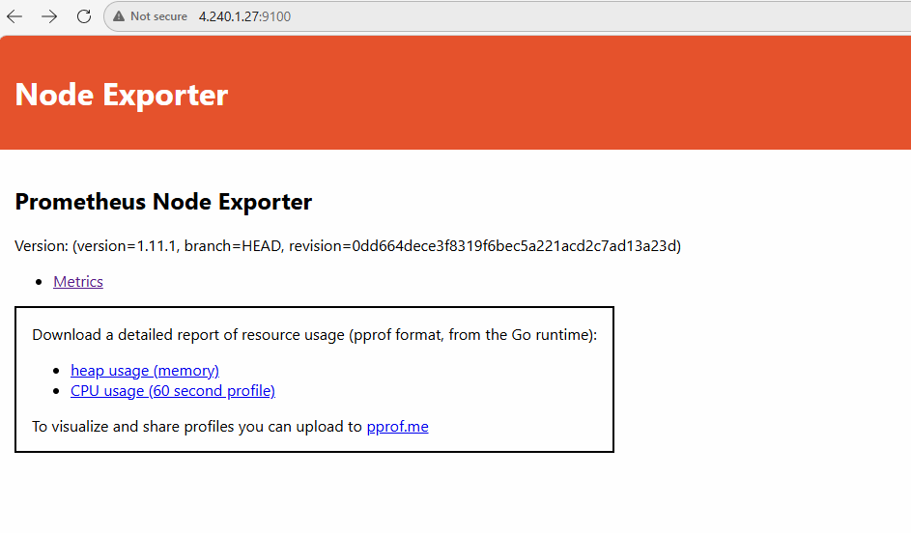

Step 19: Create Prometheus Directory
mkdir prometheus
cd prometheus

Step 20: Create Prometheus Configuration File
nano prometheus.yml

Paste:
global:
scrape_interval: 15s
scrape_configs:
- job_name: 'node-exporter'
static_configs:
- targets: ['4.240.1.27:9100']

Replace:
- PUBLIC_IP
Save file.

Step 21: Verify Configuration
cat prometheus.yml

Step 22: Run Prometheus Container
sudo docker run -d \
--name prometheus \
-p 9090:9090 \
-v $(pwd)/prometheus.yml:/etc/prometheus/prometheus.yml \
prom/prometheus

Step 23: Verify Prometheus
sudo docker ps

Expected:
- node-exporter
- rafanaus

Step 24: Open Prometheus Dashboard
Open browser:
http://PUBLIC_IP:9090

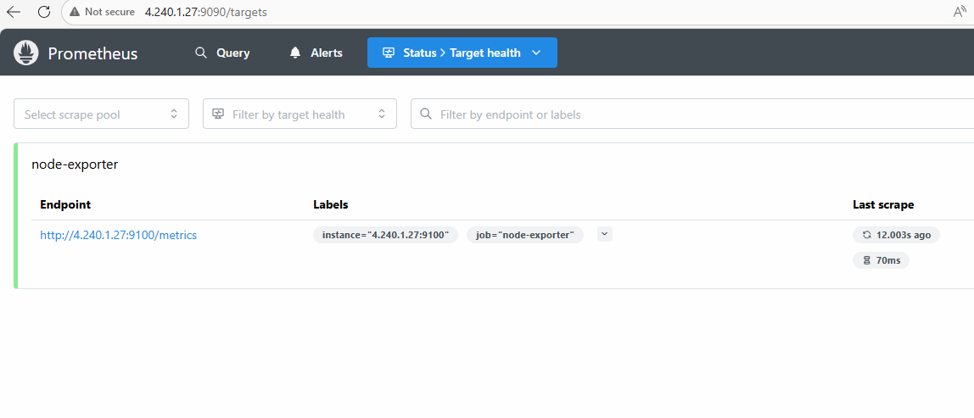

Step 25: Verify Prometheus Target
In Prometheus:
- Status
- Targets
Expected:
- node-exporter = UP

Step 26: Run Grafana Container
sudo docker run -d \
--name rafana \
-p 3000:3000 \
grafana/grafana

Step 27: Verify Grafana Container
sudo docker ps

Expected:
- grafana container running

Step 28: Open Grafana Dashboard
Open browser:
http://PUBLIC_IP:3000

Step 29: Login to Grafana
Default credentials:
Username | Password
admin | admin

Grafana will ask to change password.
Example:
- Username: admin
- Password: Admin@123

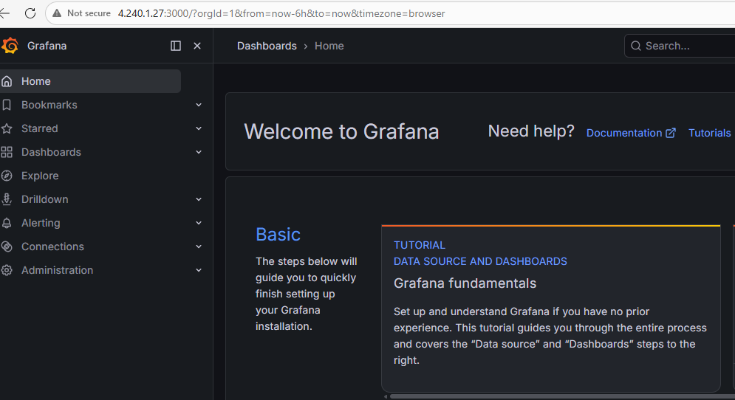

Step 30: Add Prometheus Data Source
In Grafana:
Navigate:
- Connections
- Data Sources
- Add Data Source
- Prometheus

Step 31: Configure Prometheus URL
Use:
http://PUBLIC_IP:9090

Replace:
- PUBLIC_IP
Click:
- Save & Test
Expected:
- Data source is working

Step 32: Import Node Exporter Dashboard
Navigate:
- Dashboards
- Import
Dashboard ID:
1860
Click:
- Load
Select:
- Prometheus data source
Click:
- Import
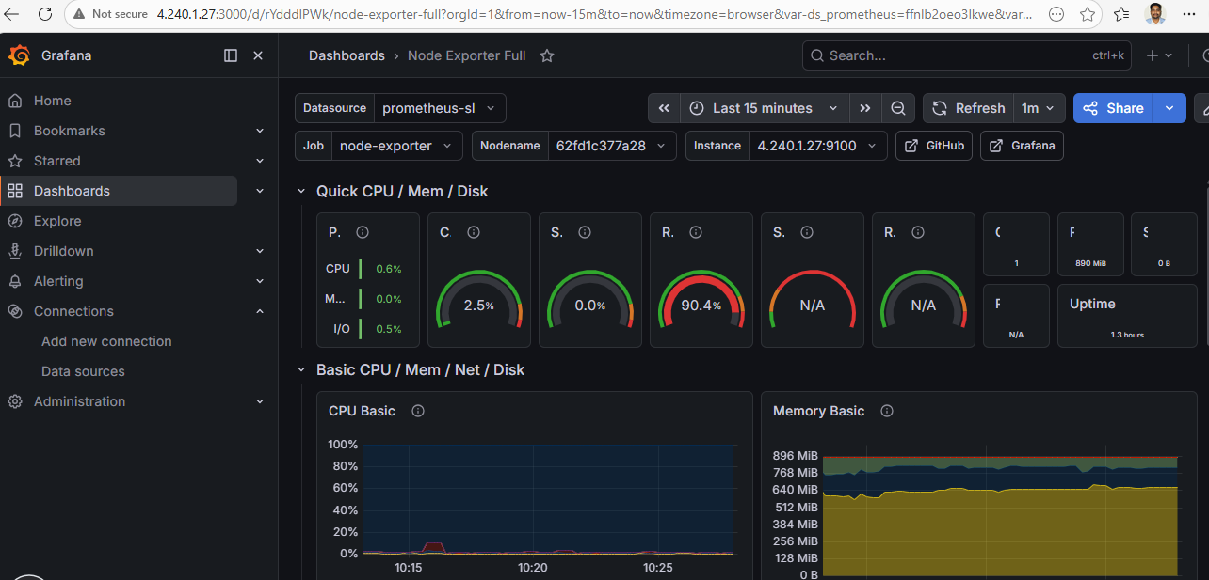

Step 33: View VM Metrics Dashboard
You will now see:
- CPU usage
- Memory usage
- Disk utilization
- Network traffic
- System load

Step 34: Generate CPU Load
Install stress tool:
sudo apt install stress -y

Step 35: Generate CPU Usage
stress --cpu 2 --timeout 60

Step 36: Observe Dashboard Changes
In Grafana dashboard:
- CPU graph increases
- System load increases

Step 37: Query Metrics in Prometheus
Example queries:
CPU
rate(node_cpu_seconds_total[1m])

Memory
node_memory_MemAvailable_bytes

Disk
node_filesystem_avail_bytes

Network
node_network_receive_bytes_total

Step 38: View Running Containers
sudo docker ps

Step 39: View Grafana Logs
sudo docker logs grafana

Step 40: View Prometheus Logs
sudo docker logs prometheus

Step 41: Stop Containers
sudo docker stop grafana prometheus node-exporter

Step 42: Remove Containers
sudo docker rm grafana prometheus node-exporter

Step 43: Exit VM
exit

Step 44: Delete VM (Optional)
az vm delete \
--resource-group rg-grafana-lab \
--name vm-monitor \
--yes

Step 45: Delete Resource Group (Optional)
az group delete \
--name rg-grafana-lab \
--yes

Expected Outcome
After completing this lab:
- Azure VM created
- Prometheus configured
- Node Exporter configured
- Grafana configured
- VM metrics visualized in dashboards
- Infrastructure monitoring implemented successfully

